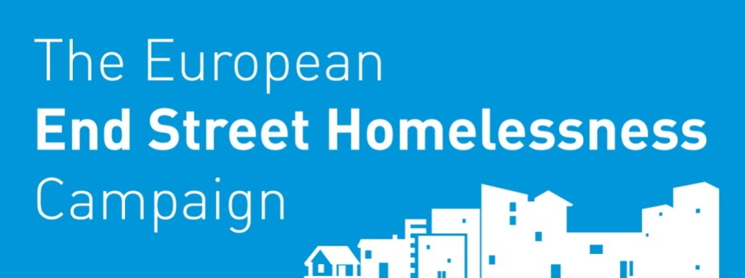

Pan-London Survey Tool

©2015 OrgCode Consulting Inc. and Community Solutions. All rights reserved.??
1 (800) 355-0420 info@orgcode.com www.orgcode.com

Administration
Interviewer’s Name | Agency | Team  Staff  Volunteer
Survey Date  DD/MM/YYYY / / | Survey Time  : AM/PM | Survey Location

Basic Information
First Name | Nickname |  | Last Name
In what language do you feel best able to express yourself?
Date of Birth | Age | Do you have a National Insurance No (NINO) | Consent to participate
DD/MM/YYYY __/__/____ |  | Yes No | Yes No
If the person is 60 years of age or older, then score 1. |  |  |  | Score:

A. History of Housing and Homelessness
- Where do you sleep most frequently? (check one)  To add  If respond sleeping outdoors state usual location:  If say sleeping in housing that is not your home ask, whose house?: | - Outdoors  - Winter/Night Shelter  - Hostels  - Temporary accommodation  - Health care institution e.g. hospital  - Prison  - Mobile homes  - Tent or other temporary structure  - Housing that is not your home/’sofa surfing’  - Family/friends  - Public Transport  - Other (specify):  - Refused
If the person answers anything other than “Hostel”, then score 1. |  |  |  | Score:
- How long has it been since you lived in permanent stable housing? |  |  | Refused
- In the last year, how many times have you been homeless or rough sleeping? |  |  | Refused
If the person has experienced 6 or more consecutive months of homelessness, and/or 3+ episodes of homelessness, then score 1. |  |  |  | Score:
B. Risks
 | In the past six months, how many times have you...
- Attended A&E? |  |  | Y |  | N |  |  |  | Refused
- Taken an ambulance to the hospital? |  |  | Y |  | N |  |  |  | Refused
- Been in hospital as an inpatient? |  |  | Y |  | N |  |  |  | Refused
- Received a service because of a crisis in your life or violent incident? e.g. Mental Health, Domestic violence, felt suicidal |  |  | Y |  | N |  |  |  | Refused
- Talked to police because you witnessed a crime, were the victim of a crime or the alleged perpetrator of a crime |  |  | Y |  | N |  |  |  | Refused
- Stayed one or more nights in a police custody or prison, whether that was a short-term stay, a longer stay for a more serious offence, or anything in between? |  |  | Y |  | N |  |  |  | Refused
- Been told by the police told you that you must move along? |  |  | Y |  | N |  |  |  | Refused
If the total number of interactions equals 4 or more, then score 1 for emergency service use. |  |  |  |  |  |  |  |  |  |  | Score:
- Have you been attacked or beaten up since you’ve become homeless/rough sleeping? |  |  | Y |  |  | N |  | Refused
- Have you threatened to or tried to harm yourself or anyone else in the last year? |  |  | Y |  |  | N |  | Refused
If “YES” to Any of the above, then score 1 for risk of harm. |  |  |  |  |  |  |  |  |  |  | Score:
- Do you have a previous criminal history that is making it difficult for you hard to find housing? |  |  | Y |  | N |  | Refused
If “YES,” then score 1 for legal issues. |  |  |  |  |  |  |  |  |  | Score:
- Does anybody force or pressure you to do things that you do not want to do? |  | Y |  | N |  |  | Refused
- Do you ever do things that may be considered to be risky like exchange sex for money, run drugs for someone, have unprotected sex with someone you don’t know, share a needle, or anything like that? |  | Y |  | N |  |  | Refused
If “YES” to Any of the above, then score 1 for risk of exploitation. |  |  |  |  |  |  |  |  |  |  | Score:

C. Socialisation & Daily Functioning
- Do you owe money to anyone? E.g. a past landlord, business, bookie, dealer, or government group like the DWP? | Y | N | Refused
- Are you getting benefits or do you receive money from cash in hand work or regular employment? | Y | N | Refused
If “YES” to question 10 or “no” to question 11, then score 1 for money management. |  |  |  | Score:
- Are you involved in any planned activities, other than just surviving, that make you feel happy and fulfilled? | Y | N | Refused
If “NO,” then score 1 for meaningful daily activity. |  |  |  | Score:
- Are you currently able to take care of basic needs like bathing, changing clothes, using a toilet getting food and clean water and other things like that? | Y | N | Refused
If “NO,” then score 1 for self-care. |  |  |  | Score:
- Is your current homelessness in any way caused by a relationship that broke down, an unhealthy or abusive relationship, or because family or friends caused you to be evicted? | Y | N | Refused
If “Yes,” then score 1 for social relationships. |  |  |  | Score:
D. Wellness
- Have you ever had to leave a flat, hostel, or other place you were staying because of your physical health? | Y | N | Refused
- Do you have any chronic health issues with your major organs i.e. liver, kidneys, stomach, lungs or heart? | Y | N | Refused
- Do you have any physical disabilities that would limit the type of housing you could access, or would make it hard to live independently because you’d need help? | Y | N | Refused
- When you are physically sick or not feeling well, do you find it difficult to ask for help? | Y | N | Refused
- FOR FEMALE RESPONDENTS ONLY: Are you currently pregnant? | Y | N | N/A or Refused
If “YES” to Any of the above, then score 1 for physical health. |  |  |  | Score:
- Have you been evicted from of a hostel or any accommodation where you were staying in the past because of drinking or drug use? | Y | N | Refused
- Will it be difficult for you to stay housed or afford your housing because of drinking or drug use? | Y | N | Refused
If “YES” to Any of the above, then score 1 for substance use. |  |  |  | Score:
- Have you ever had trouble maintaining your housing, or been evicted from accommodation or other place you were staying, because of:
- A mental health issue or concern? | Y | N | Refused
- A past head injury? | Y | N | Refused
- A learning disability, developmental disability, or other impairment? | Y | N | Refused
- Do you have any mental health or brain injury that would make it hard for you to live independently because you’d need help? | Y | N | Refused
If “YES” to Any of the above, then score 1 for mental health. |  |  |  | Score:
If the responent scored 1 for physical health and 1 for substance use and 1 for mental health, score 1 for tri-morbidity. |  |  |  | Score:
- Are there any medications that a doctor said you should be taking that, for whatever reason, you are not taking? | Y | N | Refused
- Are there any prescribed medications that you are not taking but should be? | Y | N | Refused
- Are there any medications like painkillers that you don’t take the way the doctor prescribed or where you sell the medication? | Y | N | Refused
If “Yes” to any of the above, score 1 for medications. |  |  |  | Score:
- Has your current period of homelessness been caused by a traumatic experience eg. domestic violence or some other kind of physical or emotional abuse? | Y | N | Refused
If “Yes”, score 1 for abuse and trauma. |  |  |  | Score:
Demographic Information
- What gender do you identify with? | ☐ Male  ☐ Female  ☐ Transgender  ☐ Don’t Know  ⃣ Other – specify …………………………  ☐ Decline to answer
- How would you define your sexuality? | ⃣ Heterosexual  ⃣ Gay/lesbian  ⃣ Bi-sexual  ⃣ Don’t know  ⃣ Decline to answer
- What is our country of origin?
- Are you a citizen of an EU country? | Yes (Specify)  No  Don’t know
- Have you ever been in the armed forces? | ☐ Yes  ☐ No  ☐ Don’t Know  ☐ Decline to answer
- Did you move to London in the past year? | ☐ Yes  ☐ No  ☐ Don’t Know  ☐ Decline to answer
- Are you a recent asylum seeker or refugee or migrant to the UK? | ☐ Yes  ☐ No  ☐ Don’t Know  ☐ Decline to answer
- If yes, how long have you been in the UK? | ⃣ Less than a year  ⃣ 1-2 years  ⃣ 3-5 years  ⃣ 5-10 years  ⃣ 10-20  ⃣ 20+  ⃣ Don’t know
- If you are an asylum seeker or refugee, were you dispersed to another part of the UK before coming to London? | ⃣ Yes  ⃣ No  ⃣ Don’t know  ⃣ Decline to answer
- Have you ever been in Local Authority Care? | ☐ Yes  ☐ No  ☐ Don’t Know  ☐ Decline to answer
- Have you been in custody and/or prison?  - When?  ………………………………………………… | ☐ Yes  ☐ No  ☐ Don’t Know  ☐ Decline to answer
Scoring Summary
Domain | Subtotal | REsults
Pre-survey | /1 | Score Recommendation:  0-3: Assessment and Advice/signposting e.g single service offer or NSNO  4-7: Temporary supported accommodation/Hostel  8+ Longer term supported accommodation, e.g. Permanent Supported housing/ Housing first
A. History of Housing & Homelessness | /2
B. Risks | /4
C. Socialization & Daily Functions | /4
D. Wellness | /6
Grand Total: | /17

